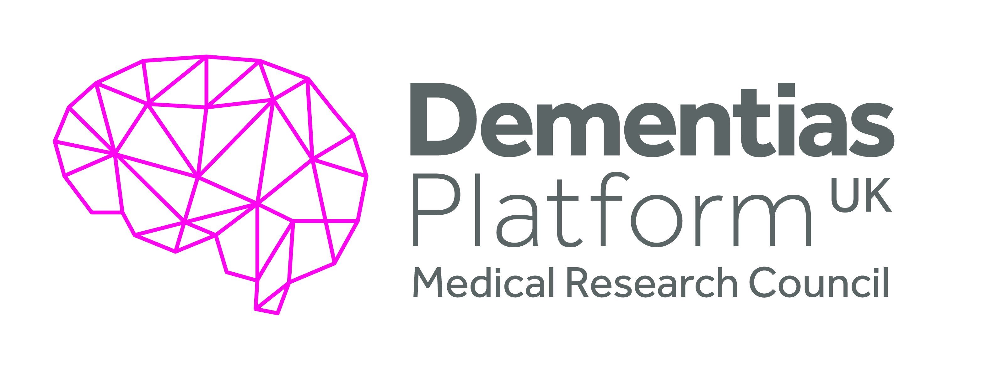
Expanding DPUK Genetics and
Integrating with inflammation/
immunity research
EM9
Objective(s):
The aim of this work was to genotype 2000 samples from individuals enrolled in DPUK cohorts and make this data available on the DPUK Data Portal. As well as enrichment of the data connected with the DPUK cohorts, the work would allow the generation of Alzheimer’s disease (AD) polygenic risk scores (PRS). This methodology has been established, and reported, as part of DPUK work package 14a Biostatistics Genetics (see https://www.dementiasplatform.uk/publications/work-package-14a-2013-biostatistics-genetics)

Overview Summary:
Work undertaken by the Cardiff AD genetics group has provided evidence that genetics has great promise in identifying individuals at high or low risk of developing AD. The team has utilised state-of-the-art statistics to develop a tool called a polygenic risk score (PRS), which helps in understanding the link between genetic and environmental risk factors for disease.

The work aimed to show the feasibility of generating genotype and polygenic risk scores within DPUK cohorts. The team selected DPUK cohorts that would be amenable to this work with available samples and relevant ethical consent. This included MRC cohorts and the CHARIOT PRO cohort. DNA from individuals in the cohorts was prepared and sent to the University of Edinburgh Clinical Research Facility which had the relevant equipment (Illumina Global Screening Array) to provide the genotypic data which was returned to Cardiff for analysis and the generation of a PRS.

The relevant data will be available on the DPUK Genetics Data Portal.
Executive Summary:
The aim of this work was to increase the genetic data available within the DPUK portal by genotyping samples available through the DPUK cohorts. The goal was to show the feasibility of enriching the DPUK portal by inclusion of genotype data and to then make this data available to the wider research community. Generation and inclusion of a polygenic risk score means that the wider community can simply integrate genetics into their research. This is an important step towards integration of differing data types and availability of large-scale data in a large number of cohorts that would be otherwise prohibitive to distribute and analyse due to security and computational restrictions. During the process the group identified challenges associated with data generation and attempted to mitigate these with increased communication. As part of the project genotype data and polygenic risk scores for over 2000 participants already enrolled in DPUK cohorts have been generated. The team conclude that increasing the availability of genotype data within DPUK is feasible and it is possible to provide a simple single variable polygenic risk score to allow the wider research community to integrate genetics into their research.
Summary of Outputs: (as per Researchfish categories)
Publications:
The project data is currently being analysed and publications will then be prepared. Publications from the Cardiff AD genetics group were reported in a separate final report (see https://www.dementiasplatform.uk/publications/work-package-14a-2013-biostatistics-genetics)
Collaborations & Partnerships
The team has coordinated a genetics network within DPUK. This network includes the following Principal Investigators: Carol Brayne, John Hardy, Peter Passmore, Kevin Morgan, John Powell, Simon Mead and Clive Holmes. Following the implementation of this network, permissions have been gathered to incorporate a variety of data to the DPUK Genetics Database and have incorporated pre-existing genetic data via upload to the DPUK analytical site.
Further Funding
This pilot project has established the viability of the approach to enrich DPUK cohorts with genetic data and the results, once fully analysed, will form the basis for further grant applications.
Next Destinations
Georgina Menzies an ECR researcher involved in leading on this project secured her own Sêr Cymru II Fellowship. She is a UK DRI Collaborating Fellow focusing on structural and functional investigations into the outcomes of genetic studies.
Engagement Activities
The team has described its engagement activities as part of the report for workpackage 14a- see https://www.dementiasplatform.uk/publications/work-package-14a-2013-biostatistics-genetics
Influence of policy, practice, patients & the public
The potential of polygenic scores was specifically mentioned by the UK Minister of Health in discussing future medical practice (2019).
Research Tools & Methods
The group has led on the development of polygenic risk scoring methodology and published extensively on this topic
Research Databases & Models
The data from this project will be available on the DPUK Genetics Data Portal.
Intellectual property & licencing
None
Medical products, interventions & clinical trials
None
Artistic & creative products
None
Software & technical products
None
Spin outs
None
Awards & recognition
None
Other outputs & knowledge/future steps
The team hope to build upon its successes by extending this pilot project, thus enriching the genetic data available on the cohorts within DPUK. Where possible, it would be helpful for the genotype information available to be standardised to provide a coherent set of variables across the cohorts, and to identify those cohorts where genotype information is lacking. This would facilitate the use of mass genotyping, allowing broader epidemiological research that can benefit the users of the DPUK portal and the scientific community as a whole.
Use of facilities & resources
The project relied on the availability of specialist equipment for genotyping at the University of Edinburgh Clinical Research Facility.
Most successful outcome and what it means for future dementia research:
Enrichment of DPUK cohorts through generation of genotype data allowing integration of genetic data and polygenic risk scores with other data types within those cohorts for future research. Genomic profiling will become pivotal in selecting therapies based on individual risk. To achieve high diagnostic accuracy, polygenic risk scoring should be linked with biomarkers, clinical and environmental information and tested for accuracy in groups of people targeting disease specific functional mechanisms.
Lessons learned:
Creation of genetic data for DPUK cohorts can be undertaken within a reasonable time frame and at minimal cost. This work was delayed by protracted negotiations around legal agreements and it is urged that DPUK undertakes work to provide a framework that streamlines the processes and provides standardised agreements which do not need to be negotiated.
Other:
Report produced 5 November 2020.

