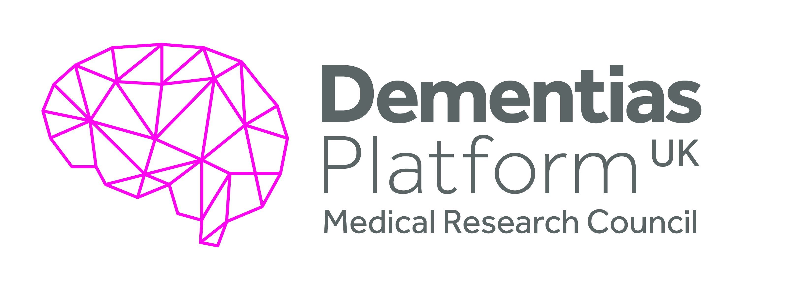
Multi-Modal Imaging
EM3
Objective(s):
This proof-of-concept study aimed to characterise the brain uptake of the novel astroglial activation imaging marker, [¹¹C] BU99008, in AD subjects compared to non-AD control subjects. Relationships between [¹¹C]BU99008 brain uptake, Abeta deposition and brain glucose metabolism will also explore how multi-modal imaging indices may inform.
Specific objectives were as follows:
- To test whether the uptake of a PET astroglial activation tracer ([¹¹C] BU99008) is increased in the brains of people with mild to moderate AD relative to age-matched healthy volunteers
- To assess the correlation of PET-detected astroglial activation with regional reduction in FDG (¹⁸F-Fluorodeoxyglucose) uptake
- To assess whether PET-detected astroglial activation co-localises with Abeta deposition.

Overview Summary:
This Experimental Medicine proof-of-concept study aimed to test the hypothesis that the uptake of a novel tracer ([¹¹C] BU99008), developed as a potential marker of astrocyte activation in brain, would be elevated in Alzheimer’s Disease(AD)/ Mild Cognitive Impairment (MCI) subjects. The results indicated that there was an increase in [¹¹C] BU99008 in AD and MCI patients compared with healthy controls. These results are interpreted to be indicative of astroglial activation. Furthermore, the uptake of the radioligand was strongly associated with amyloid deposition in AD/MCI suggesting a potential mechanistic link between astrocyte activation and amyloid deposition in the progression of AD.

Executive Summary:
The imidazoline I₂ binding sites (I₂-BSs) are widely distributed in the brain but found principally on glial cells, where they appear to have a functional role in astrocytes. [¹¹C]BU99008 is a novel PET tracer selective for I₂-BSs. The aim of this study was to evaluate [¹¹C]BU99008 uptake, a novel marker of glial activation, in subjects cognitively impaired (AD, Mild Cognitive Impairment –(MCI)- and age-matched controls. With the novel [¹¹C]BU99008 PET tracer, the team provided new in vivo evidence for an increased I₂ uptake in people with AD/MCI, potentially predominantly reflecting astroglial activation. The increased uptake was widely distributed in grey matter, where it was associated with amyloid deposition.

Summary of Outputs: (as per Researchfish categories)
Publications

Relationship between astroglial activation detected by novel [11C]BU99008 PET and amyloid deposition in subjects with cognitive impairment
Calsolaro V, Matthews PM,, Myers JFM, Fan Z, Tyacke RJ, Venkataraman A, Femminella GD, Perneczky RN, Gunn R, Rabiner EAI⁴ Gentleman S, Parker CA, Murphy PS, Wren PB, Hinz R, Nutt D, Edison P. Re-submittted.
The aim of this study was to assess the [11C]BU99008 uptake in subjects with cognitive impairment, and to assess the relationship between [11C]BU99008 uptake and amyloid load, evaluated using [18F]florbetaben. Twenty-one subjects (11 patients with cognitive impairment (AD or mild cognitive impairment (MCI)) and 10 age-matched healthy controls) were studied. The [11C]BU99008 analysis showed significantly higher tracer uptake in the disease group compared the healthy controls in frontal, parietal, temporal and occipital cortices. Individually, seven patients also demonstrated clusters of significantly higher [11C]BU99008 uptake compared to controls at voxel-level. Of these seven, six also were amyloid positive. The sub- group of amyloid-positive subjects demonstrated significant increase in [11C]BU99008 uptake compared to the controls; there was a positive correlation between [11C]BU99008 binding and amyloid load at voxel-level. Together, this work comprehensively describes the first use of this novel tracer in people with dementia, drawn from a DPUK-associated cohort. The study demonstrated that [11C]BU99008 PET tracer uptake is able to define an increase in brain astroglial activation especially in amyloid positive cognitively impaired subjects. The significant voxel-level correlation between amyloid load and astrocyte activation suggests the inter-relationship between these two processes.

The initial peer review of the publication suggested further analyses which were completed and the manuscript revised to address them.

Collaborations & Partnerships
This project was a productive one undertaken by researchers at Imperial College working with Invicro, a DPUK partner, to develop a novel radioligand.
Further Funding
None at this point
Next Destinations
Dr. Calsolaro is now back in clinical training for gerontology.
Engagment Activities:
None specific for this work
Influence of policy, practice, patients & the public
The costs for advanced PET with novel radioligands are high and remain limiting. To have broader utility, a fundamental methodology advance is needed to lower costs by approximately five fold.
Research Tools & Methods
None
Research Databases & Models
The data from this project will be available from the DPUK Data Portal following the necessary approvals.
Intellectual property & licencing
None
Medical products, interventions & clinical trials
Group are considering ways of integrating this tracer with TSPO or other microglial marker.
Artistic & creative products
None
Software & technical products
None
Spin outs
None
Awards & recognition
None
Other outputs & knowledge/future steps
None at present
Medical products, interventions & clinical trials
This group are contributors to the initatives around the MRC funded MRI-PET infrastructure development in the UK.
Most successful outcome and what it means for future dementia research:
This work demonstrated that it is possible to use novel radiotracers to conduct experimental medicine proof-of-concept trials. The in vivo approach pursued in this project provides the potential for testing mechanistic relationships directly and in turn could be used for evaluating therapeutic approaches. However, at the current time, the costs of advanced PET with novel radioligands are high, limiting applications of the methodology. The group has demonstrated the importance of use of multiple tracers simultaneously.

Lessons learned:
- The radiotracer needs further biological target data and development of a stronger capacity for cellular resolution. Post mortem tissue autoradiography would add confidence to new tracer/new target work.
- Recruiting people with Alzheimer’s disease for complex PET studies remains challenging because of the need for large populations to select those meeting study criteria and willing to consent.
Other:
None
Date of Report:
16 November 2020

