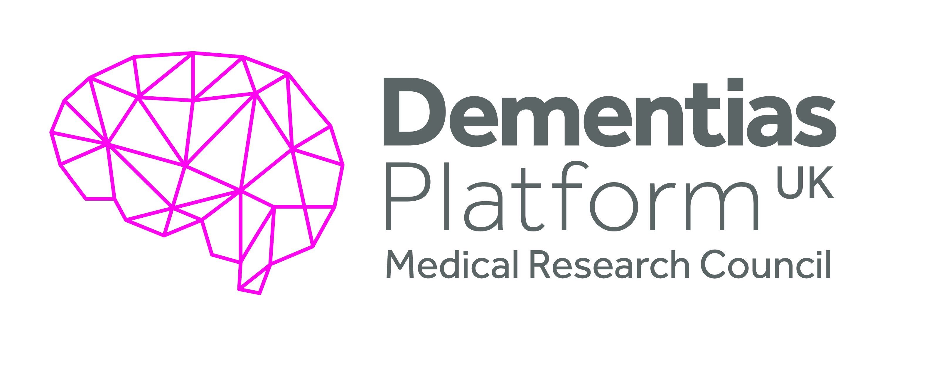
Integration of clinical and cellular
phenotypes in the DPUK Deep and
Frequent Phenotype Cohort
EM2
Objective(s):
The objective of this study was to assess the potential of Induced Pluripotent Stem Cells (iPSC) to act as model systems for neurodegenerative diseases where the critical cell types have previously been inaccessible. The capability to generate, engineer, differentiate and phenotype iPSC-derived neurons and glia from patients with neurodegeneration would uniquely facilitate the study of highly physiological human models of disease. Specifically, the team wished to understand the extent to which a stem cell neuron can be used as an individual in vitro model for personalised experimental medicine studies of neurodegenerative diseases.

A pilot study was proposed to fine tune the methodology needed to generate iPSC-derived neurons uniquely focused on the individuals from the MRC NIHR Deep and Frequent Phenotype cohort who were showing signs of very early AD or Mild Cognitive Impairment and who had undergone extensive cognitive and biological phenotyping.

Overview Summary:
The team undertaking this project has pioneered the techniques necessary to culture induced pluripotent stem cells (iPSCs) from a group of individuals (the MRC NIHR Deep and Frequent Phenotype cohort) with very early AD and Mild Cognitive Impairment and use these cells for further studies. Significant cognitive and biological testing has been conducted on the cohort to provide a wealth of data on individuals. The team aim to test whether these iPSC cells can be used as model systems that will replicate the cognitive and biological processes being undertaken in cohort members and hence provide insight into neurodegenerative diseases.

The pilot study work undertaken to date has confirmed that iPSC- derived cortical neurons can be used as model systems for further experimental studies.

Executive Summary:
The MRC NIHR Deep and Frequent Phenotype cohort is one of the most extensively assessed cohort of people with very early AD and Mild Cognitive Impairment (MCI). All participants have at baseline extensive clinical and biological assessments including detailed cognitive measures and biological measures of pathology including both Amyloid and Tau PET and molecular assays of both in CSF. Then at approximately two monthly periods for approximately one year all participants have repeat structural and functional MRI, CSF Aβ and Tau, clinical measures including cognition, EEG and MEG, optical computerized tomography, gait measures and bloods for protein arrays and other measures.

All participants were approached for consent to donate cells for induced pluripotent stem cell (iPSC) generation and all gave consent for follow up from Electronic Medical Records (EMR) and other linked data. This Experimental Medicine project has generated iPSC lines from patients obtained from the MRC NIHR Pilot Deep and Frequent Phenotype cohort. The group is undertaking pilot studies in iPSC-derived excitatory glutamatergic neurons to test the hypothesis that the cellular phenotype of iPSC-derived neurons from patients will recapitulate the deep clinical phenotyping obtained from the MRC NIHR Pilot Deep and Frequent Phenotype AD and MCI cohort.

The pilot work has confirmed that iPSC-derived cortical neurons are suitable for a large-scale analysis of multiple patient lines in vitro and can be used to address hypotheses from clinical work.

The following is a summary of the work conducted to date in preparation for the complete analysis of all lines in parallel.
- 14 iPSC lines generated from the MRC MRCDFP pilot cohort
- Neuronal differentiation conditions specifically optimised for each line to generate excitatory cortical glutamatergic neurons
- A range of Aβ treatments defined and material prepared including Aβ oligomers and controls, Aβ extracted from AD and control post-mortem brain, and Aβ depleted AD post-mortem brain
- Neurophysiological characterisation assays defined

This project is very labour intensive and remains on-going with results anticipated from 2021.

Summary of Outputs: (as per Researchfish categories)
Publications:
This is a complex project and the experimental work remains on-going.
Collaborations & Partnerships
This project involves the use of facilities provided in the DPUK Stem Cell Network. The final report from this Network is available on the DPUK website.
Further Funding
Funding Scheme: Travel grant for conference for Bryan Ng
Organisation Name: Alzheimer's Research UK
Type: Travel/small personal
Funding Amount: £600
Next Destinations
Anne Hedegaard- has now taken up a post-doctoral position at the University of Oxford.
Engagement Activities
- 2014. Richard Wade-Martins was a speaker at the launch of UK Dementia Platform.
- 2015, 2016, 2017, 2018 & 2019 Dementia Awareness Day. The Oxford ARUK Network Centre organise this event to discuss current dementia research taking place within the network centre, which includes the University of Oxford, Oxford Brookes University and University of Reading.
- November 2019. Richard Wade-Martins gave an ARUK Target Drug Discovery talk.
- 2015. Richard Wade-Martins attended the DPUK Stakeholders Meeting.
- 2016. Richard Wade-Martins gave an interview for the Civil Service Fast Stream blog about his research into dementia at which Richard discussed his DPUK work.
- 2016. Participation of the Pint of Science Public Engagement Talks, Oxford.
- 2019. Bryan Ng attended and supported the ARUK Oxford Network Research Day and gave a presentation. Bryan Ng helped out at a dementia awareness event at the John Radcliffe Hospital. This was a morning of talks about research into dementia in and around Oxford and a chance for the public to meet researchers and find out about support services available for people living with dementia.
- 2019. Bryan Ng attended the Alzheimer's Association International Conference and presented a poster.

Influence of policy, practice, patients & the public
iPSC models promise to revolutionise the study of neurodegenerative disease and the work undertaken in this study will provide details of the technology required for the use of iPSCs in personalised medicine.
Research Tools & Methods
A range of neurophysiological assays have been developed to measure the response of the iPSC-derived cortical neurons to the Aβ treatments. The assays are:

- Immunocytochemistry quantification of synapse formation (synaptophysin/Homer 1)
- Low MOI viral GFP transduction and neurite tracing imaging
- Immunocytochemsitry of neuronal morphology, cell death and phospho-tau formation
- Western blot markers (eg: phospho-tau formation)
- Somalogic array proteomics
- Transcriptomics
- Multi-electrode array analysis
- Patch-clamp electrophysiology (on selected lines only)
Research Databases & Models
iPSC lines from 14 individuals from the MRC NIHR DFP Pilot cohort have been successfully generated and banked. Please contact the study PI (Richard Wade-Martins, University of Oxford) for access to the lines.
Intellectual property & licencing
None
Medical products, interventions & clinical trials
None
Artistic & creative products
None
Software & technical products
None
Spin outs
None
Awards & recognition
Bryan Ng: £500 Early Career Researcher award from ARUK Oxford Network, June 2020, to develop improved methods of Abeta immunodepletion.
Other outputs & knowledge/future steps
None
Use of facilities & resources
This project has been undertaken using equipment purchased as part of the DPUK Stem Cell Network.
Most successful outcome and what it means for future dementia research:
The most successful outcome has been the development of efficient methodologies for the differentiation and characterisation of many Alzheimer’s patient stem cell-derived neurons in parallel. This will allow direct comparison in parallel in patients of the cellular response to an A-beta insult of an iPSC neuron in the laboratory, with cognitive decline in the clinic.
Lessons learned:
The group encountered several challenges throughout the project to do with generating and characterising many iPSC lines in parallel. Progressing cell phenotyping assays to a miniature form in 96 and 384 well plates has been essential to developing the work, as has been the use of DPUK-funded equipment purchased as part of the DPUK Stem Cell Network.

The network of the three laboratories (Wade-Martins, Lovestone and Cader) has worked together extremely well helped by a strong sense of collaboration and regular update meetings.
Other:
The complete final report with scientific outcomes described can be made available by contacting DPUK staff.
Date of Report:
11 September 2020

