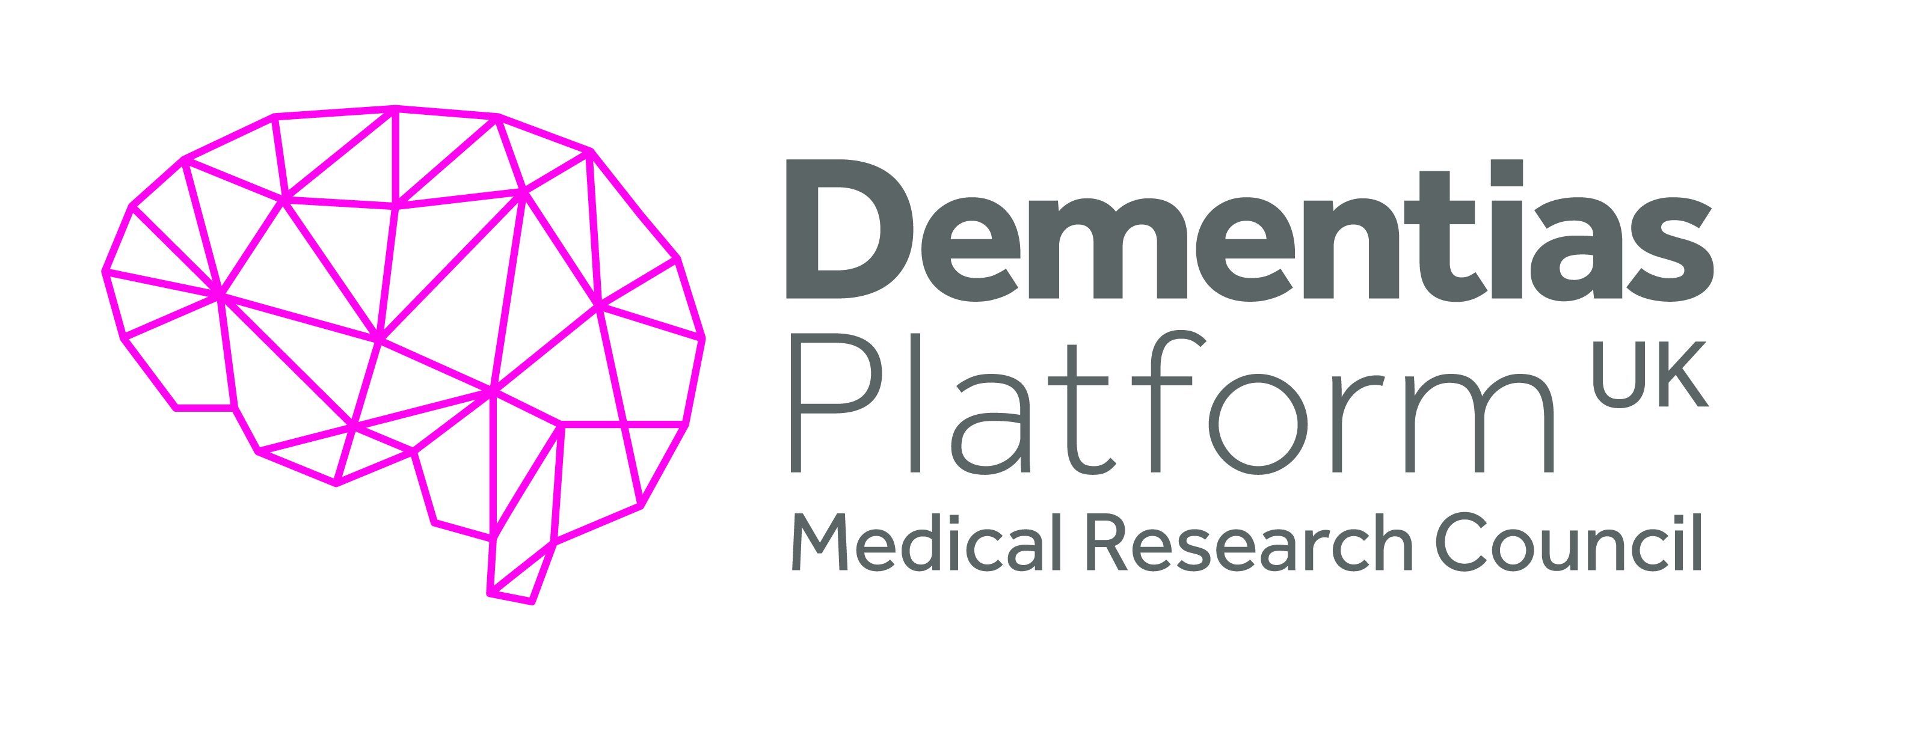
How do peripheral and central
vascular markers relate to
cognitive decline?
EM1
Objective(s):
This pilot exploratory study aimed to investigate statistical relations between measures of plasma lipidomics and lipoproteins and cognitive and neurovascular imaging parameters. The main hypothesis being addressed was that the lipidomic/lipoprotein markers will correlate with, and allow the stratification of, declines in the cognitive and neurovascular parameters.

Overview Summary:
Testing potential biomarkers of cognitive ability in late life is of interest for both theory and practice in dementia research. These biomarkers may inform about the causes of age-related cognitive decline and distinguish those who will experience pathological cognitive ageing from those who will age more healthily. This proposal was focused on lipoproteins and lipidomics with the Lothian Birth Cohort 1936 (LBC1936) providing the plasma samples for analysis.
Executive Summary:
This project aimed to investigate the potential links between plasma lipidomics and lipoproteins and cognitive and neurovascular imaging parameters that index variation in age-related decline. It tested whether these lipidomic parameters could be used to stratify subjects relevant to diverse populations with varied risk of decline in cognitive performance, vascular health and lifestyle measures. The results would potentially provide data in a pre-competitive framework that could support potential therapeutic strategies for vascular causes of cognitive impairment and dementia.

DPUK enabled many thousands of metabolites to be measured in the plasma of Lothian Birth Cohort 1936 participants, allowing investigation of their association with cognitive general ability and MRI structural brain variables.

Penalized regression models (LASSO) were used to identify sets of metabolites that predict variation in general cognitive ability and structural brain variables. UPLC-MS-POS measured lipids, together predicted 19% of the variance in total brain volume and 17% of the variance in both grey matter and normal appearing white matter volumes. Multiple subclasses of lipids were included in the predictor, but the best performing lipid was the sphingomyelin SM(d18:2/14:0) which occurred in 100% of iterations of all three significant models. No metabolite set predicted cognitive ability, or white matter hyperintensities or connectivity.

Summary of Outputs: (as per Researchfish categories)
Publications:
Harris SE, Ritchie SJ, Correia DS, Jiménez B, Fawns-Ritchie C, Pattie A, Corley J, Muñoz Maniega S, Valdés Hernández M, Starr JM, Hill D, Wren P, Bastin ME, Lewis MR, Wardlaw J, Deary IJ Plasma lipid and lipoprotein biomarkers in LBC1936: Do they predict general cognitive ability and brain structure? bioRxiv doi.org/10.1101/2020.07.09.194688.
Collaborations & Partnerships
The work has been conducted on the Lothian Birth Cohort 1936 cohort, who at the age of approximately 73 years provided plasma samples for analysis.
Analyses using these data have contributed to CHARGE Metabolomics and NeuroCHARGE consortia.
Further Funding
None
Next Destinations
Dr Stuart Ritchie is now a lecturer at King’s College, London.
Engagement Activities
Ritchie SJ., et al. Plasma sphingolipid biomarkers in the Lothian Birth Cohort 1936: Towards associations with lifetime cognitive function, Alzheimer's Association International Conference, July 2017, poster presentation.

Harris SE The Lothian Birth Cohorts: OMICS, Medical Genetics Section Talk, IGMM, University of Edinburgh, February 2018.

Harris SE The Lothian Birth Cohort: OMICS, talk at the Lothian Birth Cohorts Reunion, September 2019.

Influence of policy, practice, patients & the public
None
Research Tools & Methods
None
Research Databases & Models
None
Intellectual property & licencing
None
Medical products, interventions & clinical trials
None
Artistic & creative products
None
Software & technical products
None
Spin outs
None
Awards & recognition
None
Other outputs & knowledge/future steps
None
Use of facilities & resources
The project utilised the analytical resources at the National Phenome Centre.
Most successful outcome and what it means for future dementia research:
Identification of a set of lipids that predict 19% of the variance in total brain volume in older individuals. Our results suggest that future studies should concentrate on identifying specific lipids as potential cognitive and brain-structural biomarkers in older individuals.
Lessons learned:
- The assays were all performed successfully although there was a delay to us receiving the data for the Lipoprotein profiling using NMR spectroscopy, because the National Phenome Centre had to optimise the assay to work on a low volume of plasma.
• Writing scripts to analyse such large data sets took longer than expected, therefore the initial publication includes only cross-sectional data. Longitudinal analyses will be included in a follow-up paper.
• We decided not to proceed with initial plans to analyse the 10 lipid panel identified by Mapstone et al, 2014 as other studies failed to replicate results from this paper whilst we were acquiring our data.
Other:
None
Date of Report:
4 September 2020

