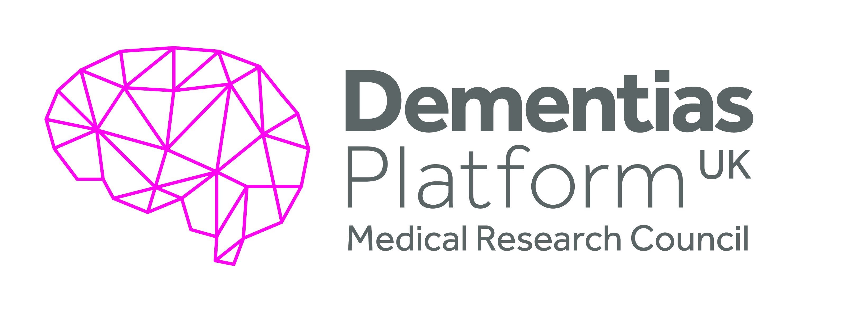
Identifying reliable change
using cognitive tests in ageing
and dementias research
Discovery Award- Dr Tom Booth, Edinburgh
Objective(s):
1. To fully evaluate the methods used to investigate individual level change in cognitive measures for dementia research (Production of a Review Article)
2. To apply IRT models to as fuller set of item level data as is possible from the DPUK cohorts to investigate individual level change.
3. To train dementia researchers in the application of optimal methods for the study of individual level change (Hosting a Training Workshop on IRT models).
4. To use the enhanced empirical understanding from (2) to design and plan a study using the trials simulation approach (Meeting to share the results).

Overview Summary:
This project arose from a DPUK Discovery Award to Dr Tom Booth, Edinburgh. It aimed to identify reliable cognitive change using cognitive tests in ageing and dementias research. More specifically, it aimed to assess the reliability of cognitive tests with the aim of establishing whether changes in individual patient test scores are significant for that individual or whether these are within the error range of the test. Outputs have included (i) the hosting of a training course on IRT models which was successfully held for over 20 researchers in autumn 2019 and (ii) a review article (complete, pending submission) and additional empirical papers ( in preparation). The Discovery Award provided an opportunity for Dr Booth to manage his own grant, an experience he has found very informative as part of his career development.

Executive Summary:
The primary aim of the project was to investigate how the use of optimal methods for assessing individual change in cognitive scores impacted the outcomes of studies of change. The broad intention was to (a) promote use of optimal methods, (b) encourage storage of data to allow such analyses, and (c) to provide useful information for quantifying the degree of error in commonly used tests for cognitive change. Aims (a) and (b) were achieved through the hosting of a training course and the writing of a review paper (submission pending). In both there were evaluations of commonly applied methods, the issues and remedies, along with applied examples. The group has made available code for optimal analyses in R. Aim (c) will be achieved by the publication of second research paper (currently in preparation). Broadly, the results demonstrate that by modelling individual change using optimal item response methods – which take into account differential reliability dependent on level of cognitive function – there is greater sensitivity in identifying individuals who have undergone change.

Summary of Outputs: (as per Researchfish categories)
Publications:
Review Article- pending submission
Murray, A.L., Vollmer, M., Deary, I.J., Muniz-Terrera, G. & Booth, T. (Under Review). Assessing individual-level change in dementia research: A review of methodologies. Alzheimer’s Research and Therapy.
Significance: Paper provides an overview of methodological approaches and issues, along with an empirical example. The example shows clearly how taking account of individual level reliability, using IRT models, changes substantive conclusions concerning change. R-code is provided to increase accessibility to suggested approach.

Empirical paper –in preparation
Murray, A.L., Muniz-Terrera, G., & Booth, T. (In Prep). Evaluating reliable change in dementia assessments using an item response theory approach. Target Journal: Journals of Gerontology - Series B Psychological Sciences and Social Sciences

Collaborations & Partnerships:
A new collaboration was initiated with Professor Steven Reise, an expert in IRT models and reliable change. Similarly, a new collaboration was established with Dr Kevin McRae-McKee at Imperial College to undertake objective 4.

Discussions have begun about continued collaboration between the research team in applying advanced psychometric methodologies to longitudinal data in ageing. Initial discussions have focused on the stability of measurement of individual difference traits and the impact of poor longitudinal measurement on change parameters.

The research team have also had a related publication accepted.

Booth, T., Murray, A., & Muniz-Terrera, G. (Accepted). Are we measuring the same thing? Psychometric and research considerations when adopting new testing modes in the times of COVID-19. Alzheimer’s & Dementia: The Journal of the Alzheimer's Association

Further Funding:
None currently but future applications are in the planning stage

Next Destinations:
None

Engagement Activities:
Dr Booth was active in the DPUK Twitter Take Over to showcase a “Day in the Life of Researchers.”

The short training workshop was very successful and over 20 researchers attended.

Influence of policy, practice, patients & the public
None

Research Tools & Methods
Open Access code made available for key analyses on submission (pending)

Research Databases & Models
A database enhancement for the LBC1936 is under discussion with Professor Ian Deary. This would involve applying for a small grant to electronically code a number of other LBC1936 cognitive measures at the item level.

Intellectual property & licencing
None

Medical products, interventions & clinical trials
None

Artistic & creative products
None

Software & technical products
None

Spin outs
None

Awards & recognition
None

Other outputs & knowledge/future steps
Teaching materials for the IRT short course on individual level change will be made freely available (https://osf.io/c7usx/)

Use of facilities & resources
Most successful outcome and what it means for future dementia research:
The Review paper, once published, will be the most influential output as it (i) clearly states a set of issues in assessing individual change, (ii) demonstrates the effects of taking these issues into account, and (iii) provides open access code to enable researchers to apply the techniques.

Lessons learned:
The management of this grant whilst dealing with significant personal change allowed Dr Booth to learn important lessons in project management for himself as a PI. He urges other researchers with significant work commitments in their home departments to carefully consider if it is possible to take on the research themselves or whether they would be better employing RAs and post-doctoral RAs on funded grants.

Other:
The DPUK data portal provided data that was fundamental to the undertaking of this project.

Date of Report
7 September 2020

